Friday 18.2.22
Home learning

Writing
Look out of the window and watch how the wind makes things move. Write a list of adjectives – describing words – about how things move in the wind. Can you think of more than 20 words?
Begin to write a poem – remember they don’t have to rhyme – using words from your adjectives list. Look at the examples to help you with ideas.
Maths
We have been learning our 2,5,10 times tables at school this week. Practise counting in 2,5 and 10s. Write out the 2 times table showing the grouping that matches each equations. Then do the same with the 5 and 10 times table
1 X 2 = 2

2 X 2 = 4

Art
Watch the video about Thomas Dambo.
https://www.youtube.com/watch?v=1RFo_OxUKfo&ab_channel=DWEuromaxx

Draw your favourite Troll or draw one of your own design. Remember to look at the shapes and draw what you see. Enjoy!

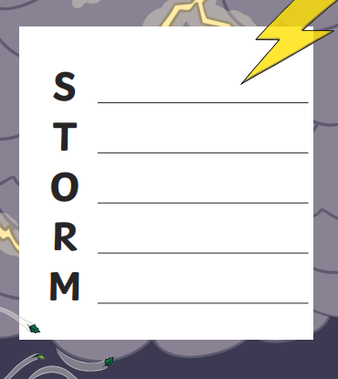

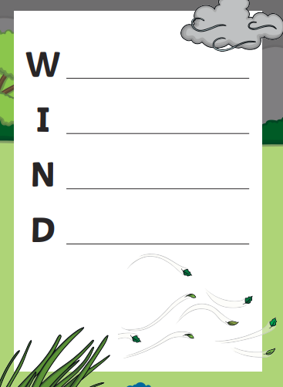

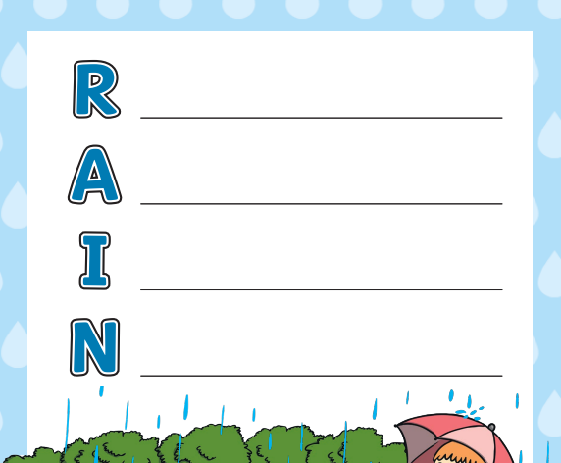

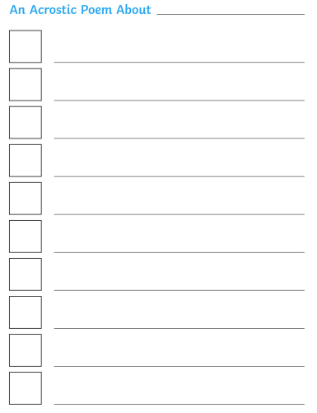
Miss Pullinger’s Storm Acrostic Poem

Storm Eunice is here

The wind is howling

Oak trees are swaying

Rain is falling heavily

Missing school, but staying safe

Mrs Parsons’ Star Challenge Poem!

The Wind

The wind howls,
The rain falls.
Little children safe indoors.

The trees shake,
The leaves fall.
Little children keeping warm.

Raindrops dribble down the wall,
Little children watch them fall.

The windows rattle,
The chimney cries.
Little children safe inside.

