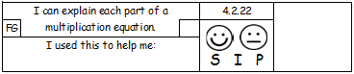
Write the multiplication equation underneath
the pictures of these paired items.
 | 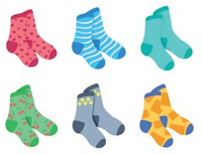
 | 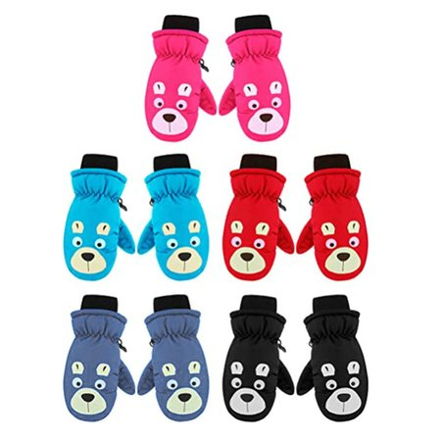
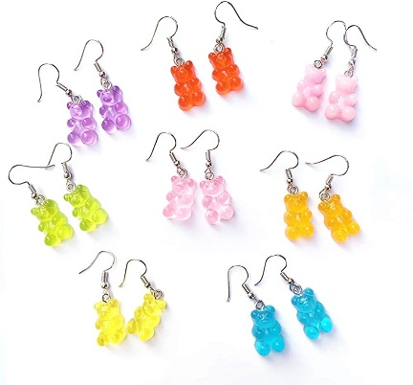 | 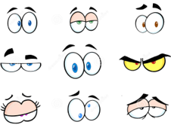

In the box below, draw your own pairs picture and write the multiplication equation underneath.

